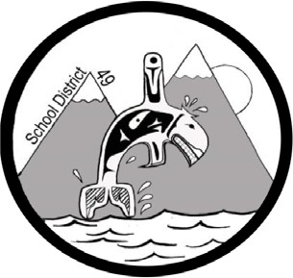
SCHOOL DISTRICT #49 (CENTRAL COAST)

Administrative Procedures Manual

Administrative Procedure: G-4 Material Distribution

Date: April 13, 2004 Updated: November 30, 2018

Commercial organizations offer many materials for use by teachers in the classroom. Some of these materials are of high educational value with little or no advertising emphasis. Other materials are primarily advertising and have only limited educational value.

Advertising materials of commercial, political or religious nature should not normally be displayed or distributed in schools or on school grounds. Students may not be used as the agents for distributing non-school materials to the homes without the approval of the Superintendent.

Page 1 of 1

