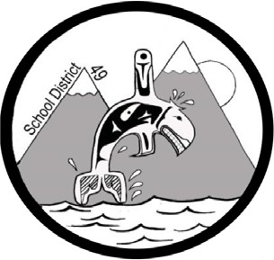
SCHOOL DISTRICT #49 (CENTRAL COAST)

Administrative Procedures Manual

Administrative Procedure: G-7 Boarding Allowance

Date: January 10, 2010 Updated: November 30, 2018

- A boarding allowance may be paid, upon application to the Board, to parents whose children are compelled to live away from their family home to attend school.

- Boarding allowance shall only be paid to parents of students who reside in an area where suitable schooling is not available

- The amount of the boarding allowance shall not exceed the amount recognized by the Ministry of Education, and shall be $350.00 per month per student.

- Boarding allowance shall only be paid for students attending school outside the district if suitable educational facilities are not available within the district.

