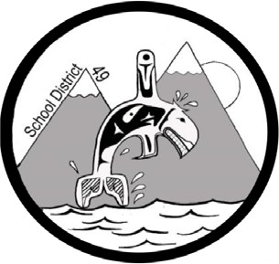
SCHOOL DISTRICT #49 (CENTRAL COAST)

Administrative Procedures Manual

Administrative Procedure: I-4 District Scholarship and Award

Date: January 14, 1997 Updated: November 30, 2018

The purpose of the District Award is to acknowledge excellence in learning fields other than academic and to provide qualifying students with a $500.00 award. A further
$500.00 District Scholarship is available to District Award Winners who proceed to a post-secondary institution to pursue career oriented studies.

Candidates shall:

- Display achievement in their chosen field of learning by submitting a piece of work or project of quality for assessment by the Scholarship Committee.

- Achieve an average letter grade or equivalent grade point average over the Grade 12 year of at least C+.

- Consult with a teacher on the appropriate specialty areas regarding the project.

- Students may supply a letter of recommendation from the appropriate teacher in the specialty area.

- Candidates must meet the basic eligibility requirements as listed for the current Province of B.C. Scholarship and Awards Program.

- Each student must submit a District Application Form to the school Principal.

- Each school will submit the names of candidates for the award whom they wish considered, with the appropriate support information and completed project to the District Scholarship Committee not later than May 31st.

- The District Scholarship Committee shall consist of:
  - the Principal of the Secondary School or designate,
  - a Trustee or the District Superintendent of Schools,
  - one member of the community, nominated by Trustees at the May meeting.

- The decision of the District Scholarship Committee will be final.

Note: Students of independent schools and correspondence students are eligible.

