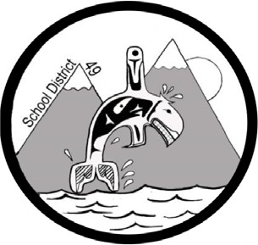
SCHOOL DISTRICT #49 (CENTRAL COAST)

Administrative Procedures Manual

Administrative Procedure: I-5 Home Education

Date: August 26, 2003

Parents choosing to register their children as home education pupils with a school in this district shall be required to:

- Register their child with the appropriate school on or before the last school day in September in accordance with the Act. All information required for the registration of a regular pupil shall be provided to the school.

- The School shall provide evaluation and assessment services and authorized and recommended educational resource materials.

- The Board may allow a home education pupil to attend an educational program offered by the Board.

- The School may provide other print or audio-visual materials currently stocked by the school, with the understanding that regular classes have priority in booking such materials. The School may require a deposit on loaned materials,

- In order to offer as many opportunities as possible to maintain contact with their peers in the school setting, home educated pupils will be welcome to attend school sponsored artistic or cultural performances if accompanied by a parent or guardian.

- Participation of home instruction pupils in non-educational programs or extra- curricular activities will be welcomed.

- Home instruction students will have access to Internet Services

