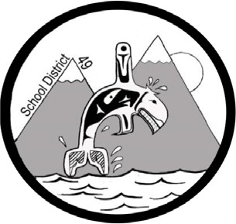
SCHOOL DISTRICT #49 (CENTRAL COAST)

Administrative Procedures Manual

Administrative Procedure: I-6 Student Reporting

Date: October 11, 2016 Updated: November 30, 2018

Administrators in consultation with teachers have been provided the choice of using either MyEdBC or the E-Portfolio format for reporting student progress to parents. If one chooses MyEdBC, then Schedule 1 of the Student Progress Report Order (as amended July 1, 2016) will apply. If one chooses to follow Schedule 2 of the Student Progress Report Order and use the portfolio format, then they must follow the guidelines contained herein.

Outlined below is what is required if reporting in the portfolio format.

There are three types of posts that are required in a portfolio: Snap Shot, Celebrations and Summaries of Learning.

- Snap shots will:

    - Be titled.
    - Be tied to an identified learning outcome or big idea from one or more curricula areas.
    - Include authentic evidence (work sample, photo, video, or audio).
    - Include descriptive feedback or evaluative component.

  - Every year there must be:

    - Three (3) Literacy Snap Shots including a written work sample marked with the BC performance standards (or equivalent)
    - Three (3) Numeracy Snap Shots.
    - Two (2) each of Science, Social Studies, PE, Arts, and Second Language(for grade 5 and higher) Snap Shots.

  - This is a total of 14-16 snap shots per year, unless one post covers two learning areas.

  - Separate posts are not required for:

    - Integrate Inquiry/Play
    - Communication

    - Creative or Critical Thinking
    - Personal and Social Responsibility.
    - They can be included in to the Core Learning Snap Shots (listed above).

- Summary of learning to be communicated to parents in March and June

  - The purposes of the summary of learning are to communicate student progress in relation to a provincial standard and communicate progress in competencies (thinking, communicating, personal and social responsibility).

  - Summaries will:
    - Be titled.
    - Include student’s progress in relation to the learning outcomes in literacy and numeracy in March and for all subjects required under the required Areas of Study Order in the end of year Summary.
    - Have a self-assessment of the core competencies in the June Summary.
    - Comment on social responsibility.

  - The terms – ‘assigned’ and ‘promoted’ must be used and defined in the end of the year summary.

  - This will be sent as a paper copy home. A copy of this will be given to the principal and added to the student file.

- Celebrations of learning will:

  - Communicate to parents/guardians at the teacher’s discretion.
  - Examples include
    - Receiving a certificates
    - A funny moment
    - Helping out
    - Field trip highlights
    - Classroom activity highlights
    - Extra-curricular activities involvement
    - Work samples
    - Communicated to parents at the teachers discretion

Page 2 of 2

