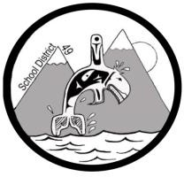
SCHOOL DISTRICT #49 (CENTRAL COAST)

Procedure

Administrative Procedures: O-10 Development and Review of Administrative Procedures

Nov. 16, 2022

Background
It is the mandate of the Superintendent to develop administrative procedures as needed to provide direction and consistency in management and decision making, and the Superintendent may develop such other procedures as deemed necessary for the effective School District operations.

The development of administrative procedures is generally preferred to be done in consultation with principals, district leadership, and, where appropriate, district staff.

Procedures shall be consistent with legal requirements, British Columbia Government statutes and regulations and Board policies.

The Superintendent, or designates, are responsible for monitoring procedures on an ongoing basis.

Development
- Development of a specific administrative procedure may be initiated by any school district administrator at any time at the request of, or through a request to the Superintendent.
- A draft of any proposed administrative procedure will be made available to school district administrators for review for five (5) working days prior to a final version being posted to the school district website.
- All newly developed administrative procedures and changes based on reviews of current administrative procedures shall be communicated expeditiously to school district staff.

Review
- A review of a specific administrative procedure may be initiated by any stakeholder at any time through a written request to the Superintendent.
  - The request will be expected to detail the issues and concerns associated with the administrative procedure and if possible, offer suggestions for revision.

