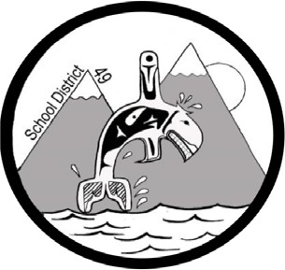
SCHOOL DISTRICT #49 (CENTRAL COAST)

Administrative Procedures Manual

Administrative Procedure: S-10 Code of Conduct Infractions Suspension Procedures

Date: November 10, 2020

The school's response to code of conduct violations will be rational, consistent, and fair. Student's who do not abide by the Code of Conduct may be subject to disciplinary measures. Disciplinary measures, whenever possible, should aim to be restorative rather than punitive in nature.

- Guidelines for Suspension
  - A student is subject to the disciplinary authority of a principal, or principal
designate, throughout the school day, while at school, on the way to and from school, and while on school sponsored activities.
    - School sponsored activity is defined as any student activity sanctioned by the school, but not limited to events such as field trips, skating, dances, etc.
  - The principal or designate is authorized to impose a suspension of up to five
(5) days without prior consultation with the Superintendent when a student fails to comply with the school code of conduct.
  - In extenuating circumstances, the principal may recommend to the Superintendent a suspension of more than five days.
1.5 The principal, or designate, may remove a suspension he/she has imposed on a student.

- Procedures
  - The principal shall immediately or as soon as practical, notify the parents by telephone, if possible and shall confirm the details by letter to the parents with a copy of the letter to the pupil and to the Superintendent.
  - A student may be denied re-entry to school until such time as an interview is held between the parent/guardian, student and principal.
  - Pupils suspended under this policy are denied entry to the school and its property during the period of suspension. Suspended pupils are expected to take their books, home and carry on independent study.
  - Students and parents have the right to appeal the suspension to the
superintendent.

- Intent of the Suspension
  - Suspensions may have one or more of the following objectives to:
- improve and/or correct student behaviour
- deter other students from similar behaviour
- plan proactive educational interventions
- clarify and solve problems
- protect the suspended student and/or other students/staff form dangerous behaviours
- provide or develop restorative justice opportunities

