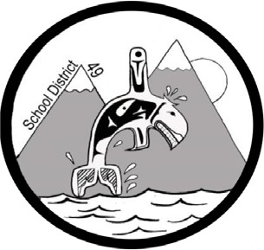
SCHOOL DISTRICT #49 (CENTRAL COAST)

Administrative Procedures Manual

Administrative Procedure: S-5 Healthy Food Choices

Date: October 12, 2010 Updated: November 30, 2018

These procedures reflect the Board's belief in the role that students are offered food choices that are healthy and nutritious. This belief has evolved in light of research concerning that long-term impact of diet on children's health and well-being.

Good nutrition can promote brain development, increase immune function, raise self- esteem, reduce anxiety, depression and hyperactivity, increase attendance, increase cognitive development and reduce the risk of health problems such as those associated with obesity.

These procedures apply to all food and beverages sold to students in all school locations, including vending machines, concessions and cafeterias, and at fundraisers, other special events and meetings.

- School staff should work together with students and parents to support and promote nutritious food choices by students from Preschool to Grade 12.
  - All food and beverages sold in schools should meet the following interim guidelines, as defined in Guidelines for Food and Beverage Sales in B.C. Schools
  - Food and beverages sold in cafeterias and concessions and through other means, combined, will meet the above guidelines.
  - These mechanisms may include such things as making healthier choices more plentiful, more visible and less expensive than their less healthy counterparts.

- Food and Beverages Provided Free of Charge in Schools - although no specific regulations apply with respect to food and beverages provided free of charge to students, schools should use the guidelines as recommended standards for practice.

  - This includes food provided to students as rewards or incentives, as well as food offered in conjunction with celebrations or other class or school activities.
  - Schools are encouraged to use alternatives to food as a reward in the classroom.

- Schools need to ensure that students have sufficient time to wash their hands before eating and are able eat snacks and lunches in a safe environment.

- Schools need to ensure safe preparation and handling of food.

